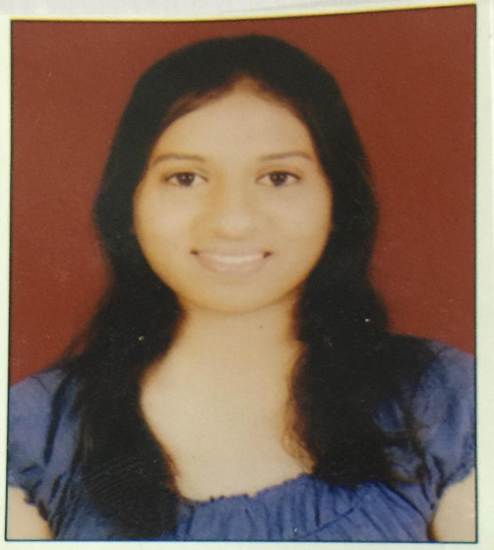

Shweta Rao

She has been working on New India School for two years. She teaches Maths Science and Geography. She has successfully completed my internship at Sanskriti School, Bhukum from July 20th 2016- 6th October 2016 where she conducted activities and lessons in maths and science for students of grade 5. She has also completed my internship from New English Medium School for a period of one month where she conducted activities and lessons in maths and science for students of grade 8.

___________________________________________________________________________

Lesson plan:            NATURAL CALAMITIES

5th grade

Time: 5 periods

Objectives:

At the end of the lesson, students of grade 5 will be able to:

1. List the natural calamities by watching a video [Natural Disasters - An Informational Short Film](https://youtu.be/iXjPn0EG-rI)

<https://youtu.be/iXjPn0EG-rl>

1. Recognize tsunamis are caused by gravitational pull of the moon by watching TED-Ed   https;//youtu.be/Wx9vPv-T51l

1. Differentiate between natural and man-made calamities by observing the educomp video
2. Relate the effects of floods to recently occurred floods in Kerala, India by watching a news clip https://youtu.be/EG1wcVEjGx0
3. Compare man made and natural calamities by finding information on the internet.
4. Value the role of people who help those affected by natural calamities by writing an article on how students will volunteer for the flood affected people on OneNote.

1. Read the weather forecast and make a chart showing the states receiving maximum and minimum rainfall in India in the year 2018.

Period 1

Knowledge (Remembering)

1. Student can define natural calamity.
2. Student can list examples of natural calamity.
3. Student can list examples of man-made calamity.

Method:

1.Teacher narrates an incident of an occurrence of a flood and how it affected the lives of people.

2.Students will watch a video to understand what 'Natural Calamities' mean and their types.

[Natural Disasters - An Informational Short Film](https://youtu.be/iXjPn0EG-rI)

Students will answer the following questions:

1. What did you observe in the video?
2. What were the reasons of the destruction?
3. Would it be possible to prevent these destructions?
4. On what scale are these destrctions caused?
5. How long would the effects of this destruction last?
6. What are the effects of this destruction?

1. Teacher asks students to make a mind map using popplet on natural and man made calamity with appropriate examples.

         Period 2

         Explore/Explain

     1. Student can identify the type of natural calamity

     2. Student can explain the causes of floods and earthquakes.

Method:

1. Teacher shows a video on the causes and effects of floods and earthquakes.

Link-1 .  [causes of flood](https://www.youtube.com/watch?v=GQ-iWUkg4t0)

         2.  [causes of earthquake](https://www.youtube.com/watch?v=T0AEtX-uPLA)

1. Teacher asks students to form groups and make a PowerPoint presentation on floods and earthquakes as a natural calamity.
2. Teacher presents a mind map on types of calamities.

<<popplet.jpg>>

Home assignment:

Make a record and dispay it on a chart on MS Word on the states receiving maximum and minimum rainfall in India in the year  2018 and write about the causes of floods in ten to fifteen sentences.

Period 3

Extend (Apply/Analyse)

In this level,  students learn that earthquakes can cause other natural disasters like tsunami or landslides.

Teacher shows a video which explains why tsunamis are caused.

https;//youtu.be/Wx9vPv-T51l

A tsunami is a very large and powerful wave caused by earthquakes under the sea. On 26th December 2004, a Tsunami hit Thailand and other parts of India such as the Andaman and Nicobar Islands, and the Tamil Nadu coast.

1. Teacher shows a video of the Tsunami occurred in Tamil Nadu in India in the year 2004.

[tsunami chennai](https://www.youtube.com/watch?v=my4UD9Wfqvk)

1. Teacher provides a link to students which gives information on what to do during an earthquake.

[steps to take during an earthquake](https://www.ses.vic.gov.au/get-ready/quakesafe/what-to-do-in-an-earthquake)

1. Teacher asks students to write the important points of the information and read it on OneNote using Immersive reader.

Home assignment

Collect information on NGO's which provide services like medicine, food and clothing to flood affected people and write about it in your notebook on OneNote.

Period 4

Synthesis

Students at this level will combine ideas learnt from the lesson and other sources. They will relate the effects of floods to the recently occurred floods in Kerala, India in 2018.

Teacher shows a news clip of the floods occurred in Kerala

https://youtu.be/EG1wcVEjGx0

Method:

1. Teacher shows a simulation on floods which gives an idea about the Elevation Map of India and Topographic conditions.

[www.floodmap.net/Elevation/CountryElevationMap/?ct=IN](http://www.floodmap.net/Elevation/CountryElevationMap/?ct=IN)

1. Teacher asks students to make a record of weather forecast in Kerala in the period of July and August on OneNote.
2. Teacher shows a video of news report of floods occurred in Kerala 2018

[news report, Kerala Floods](https://www.youtube.com/watch?v=BhIiUkq_8CI)

  Home assignment:

  Using OneNote, draw a table showing the weather forecast of 5 days in your city during the month of July 2018. Record the results and write a short paragraph on the importance of weather forecast of a natural calamity such as a flood or cyclone.

Period 5

Evaluate

The students will value the role of people who help those affected by natural calamities.

Method:

Teacher will present the following situation in class and ask students to write a report in ten to fifteen sentences using MS Publisher.

Suppose you are one of the volunteers who went to the Andaman and Nicobar Islands for relief work after the tsunami that affected them. You work in a relief camp distributing food, water and medicine among the victims. You listen to various stories of bravery of ordinary people even as they fight against the odds to bring about some semblance of normalcy in their lives. Write a report on a day spent with the tsunami affected people.

Students will read their report in class using Immersive reader in OneNote.